Screenshots (Desktop View)

Figure 1: Desktop View pt1
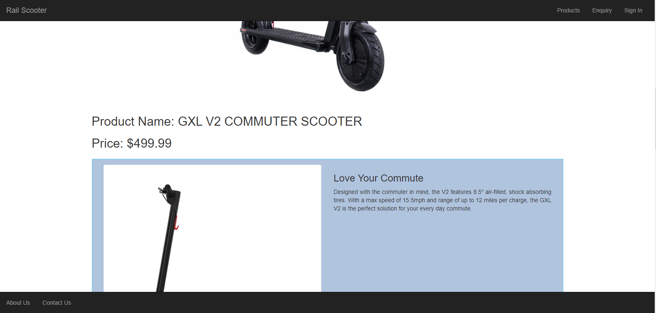
Figure 2: Desktop View pt2
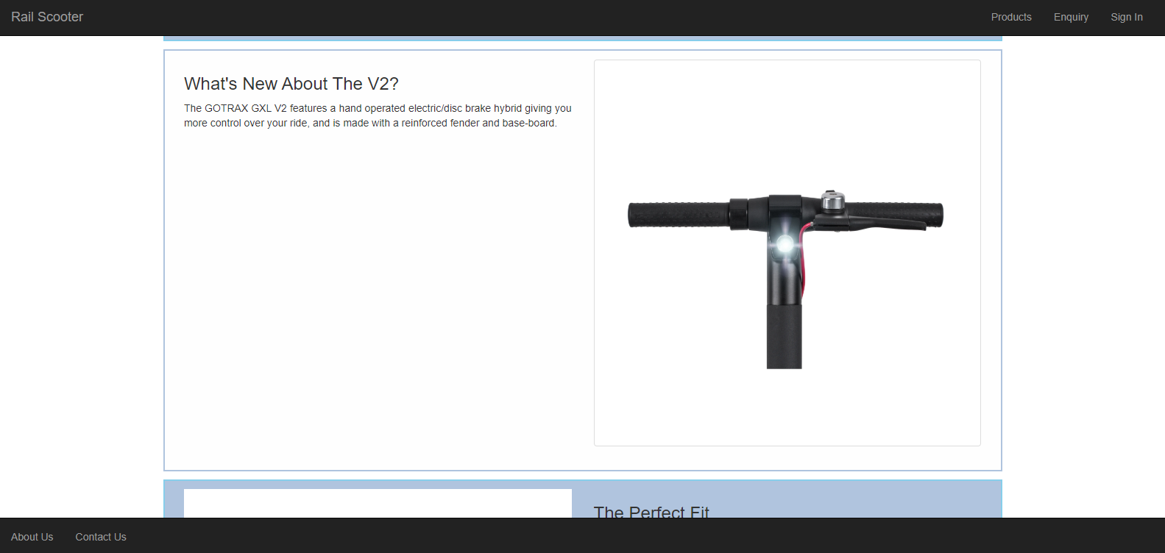
Figure 3: Desktop View pt3
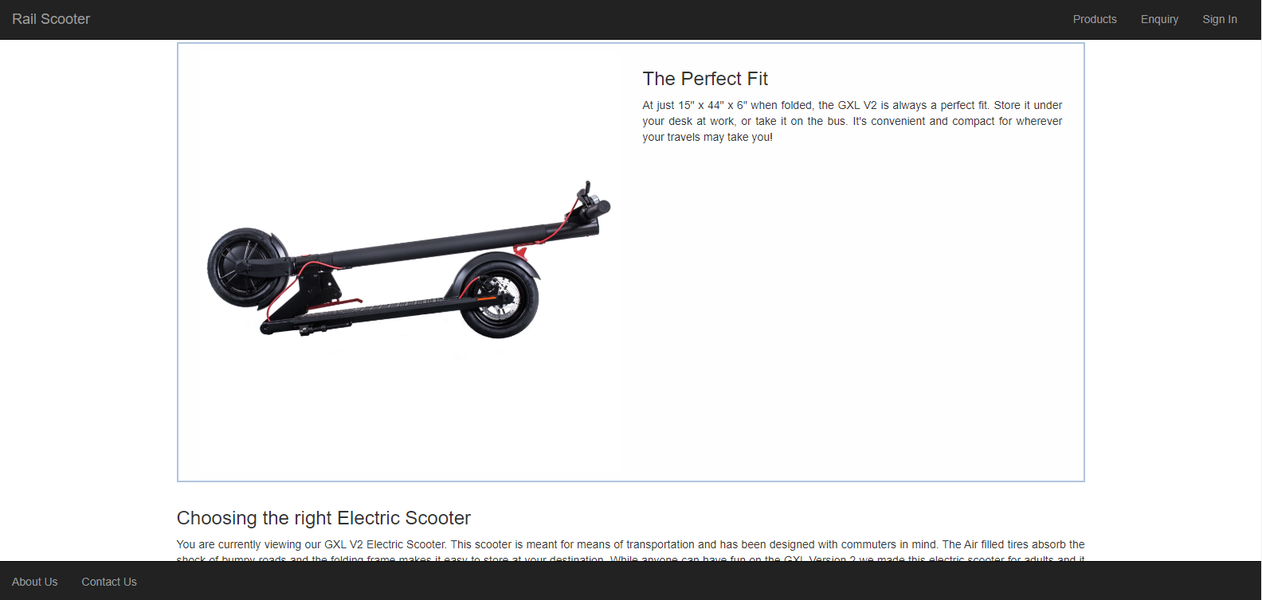
Figure 4: Desktop View pt4
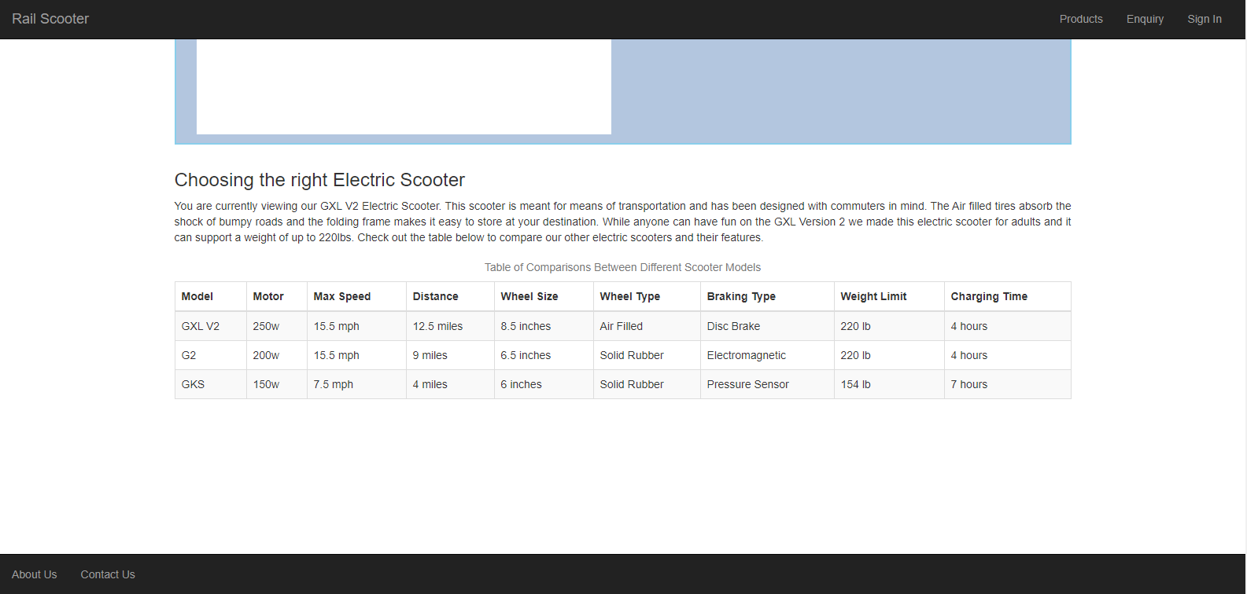
Figure 5: Desktop View pt5

Screenshots (Mobile View)

Figure 6: Mobile View pt1

Figure 7: Mobile View pt2

Figure 8: Mobile View pt3
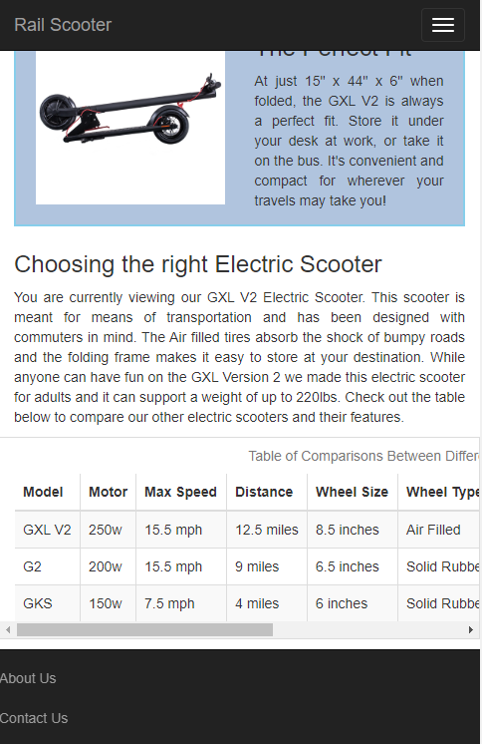
Figure 9: Mobile View pt4

